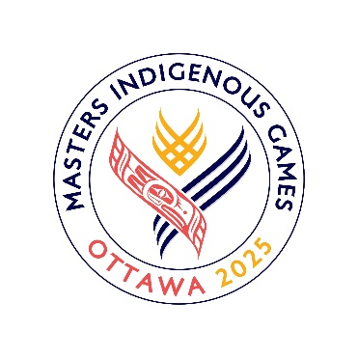

**Thursday, Aug. 14**

|  |  |
| --- | --- |
| 9AM – 4  6PM – 9 | Arctic Sports Coach & Official Clinic  Opening Ceremony |

**FRIDAY Schedule, Aug. 15**

|  |  |
| --- | --- |
| 12:00 PM  6:30 PM | Cultural Village Arctic Sports Demo  Registration Check-In |
| 7:00 PM | Arctic Sports Opening Ceremony |
| 7:30 PM | One-Foot High Kick |
| 8:45 PM | Dene Stick Pull |
| 9:45 PM | Awards |

**SATURDAY Schedule, Aug. 16**

|  |  |
| --- | --- |
| 11:00 AM | Registration Check-In |
| 12:00 PM  1:15 PM  2:15 PM | Inuit Stick Pull  Scissor Broad Jump  Alaskan High Kick |
| 3:30 PM  5:00 PM | Two-Foot High Kick  Seal Hop/Knuckle Hop |
| 6:00 PM | Awards |

**Location of Events:**

Lansdowne Park

Algonquin College Recreation Center

(1385 Woodroffe Ave.)